Content Coupling

📌 Definition:
# Source: AI Source: Provided by: [Data Path: Persons Table -> ID Column: 1, Name_En Column: Motasem Essam] -> From: [Chatgpt (GPT‑5 Mini)] on [12/9/2025]
Content Coupling occurs when one class/module directly accesses or modifies the internal data or code of another class/module.

🧠 Simple idea:
# Source: AI Source: Provided by: [Data Path: Persons Table -> ID Column: 1, Name_En Column: Motasem Essam] -> From: [Chatgpt (GPT‑5 Mini)] on [12/9/2025]
“One module knows and uses the insides of another” ⚠️

🔍 Key characteristics:
# Source: AI Source: Provided by: [Data Path: Persons Table -> ID Column: 1, Name_En Column: Motasem Essam] -> From: [Chatgpt (GPT‑5 Mini)] on [12/9/2025]
- Very tight dependency
- ❌ Hard to maintain and test
- ❌ Changes in one module break the other
- ❌ Violates encapsulation

📊 Example of Content Coupling (Bad Practice):
# Source: AI Source: Provided by: [Data Path: Persons Table -> ID Column: 1, Name_En Column: Motasem Essam] -> From: [Chatgpt (GPT‑5 Mini)] on [12/9/2025]
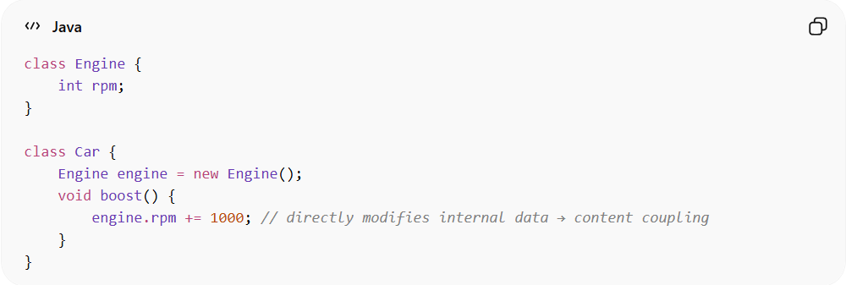
class Engine {
int rpm;
}

class Car {
Engine engine = new Engine();
void boost() {
engine.rpm += 1000; // directly modifies internal data → content coupling
}
}
- ✅ Car directly changes Engine’s internal field (rpm) → high risk
- ✅ Any change in Engine structure can break Car

🛡️ Avoiding Content Coupling Example:
# Source: AI Source: Provided by: [Data Path: Persons Table -> ID Column: 1, Name_En Column: Motasem Essam] -> From: [Chatgpt (GPT‑5 Mini)] on [12/9/2025]
To avoid content coupling, we should not let Car access Engine’s internal data (rpm) directly. Instead, we provide a method inside Engine to handle changes. This preserves encapsulation.
Here’s the improved version:
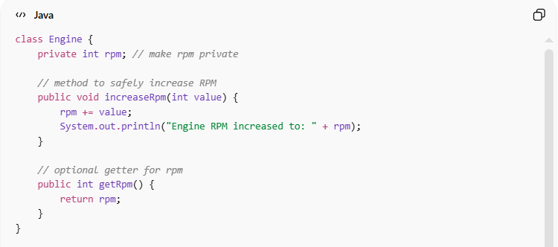
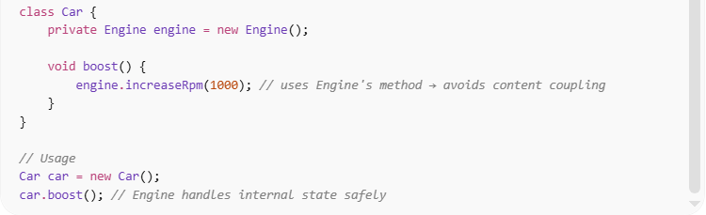
class Engine {
private int rpm; // make rpm private

// method to safely increase RPM
public void increaseRpm(int value) {
rpm += value;
System.out.println("Engine RPM increased to: " + rpm);
}

// optional getter for rpm
public int getRpm() {
return rpm;
}
}

class Car {
private Engine engine = new Engine();

void boost() {
engine.increaseRpm(1000); // uses Engine's method → avoids content coupling
}
}

// Usage
Car car = new Car();
car.boost(); // Engine handles internal state safely

✅ Key improvements:
- Engine.rpm is now private, so other classes cannot modify it directly
- Car uses a public method (increaseRpm) → no direct access to internal data
- Encapsulation is maintained, reducing content coupling

⚙️ Best practice:
# Source: AI Source: Provided by: [Data Path: Persons Table -> ID Column: 1, Name_En Column: Motasem Essam] -> From: [Chatgpt (GPT‑5 Mini)] on [12/9/2025]
- Avoid direct access to internal data
- Use getter/setter methods or interfaces to reduce coupling
- Prefer loose coupling wherever possible

